**Operating Systems and How Applications Work**

* To run any application OS creates a Process.
* Each Process gets cpu share, Memory and Disk and Network based on the process which you are running.
* Each Process will have unique identifier (id)

**Command Line**

* Every Command is a computer program/Executable
* Commands have two types of arguments by the way you pass the values
  + positional argument: This argument is processed based on position  
    cp 1.txt 2.txt  
    cp 3.txt 1.txt
  + keyword argument: In this case around the argument you will pass a name or a keyword. Generally linux style name arguments have two hyphens -- if you pass the keyword an single - if you pass the shorthand notation  
    ping -c 2 google.com  
    ping google.com -c 2  
    ping --count 2 google.com
* Every command line generally has a documentation which we call as manual. Lets start using manual to figure out what commands can do
* When you type any command every operating system has a location where the folders to be searched are configured. This is done by a variable (Environmental variable) called as PATH

**Approach to work with commands**

* What does the command do.
* Use --help or man <command>  
  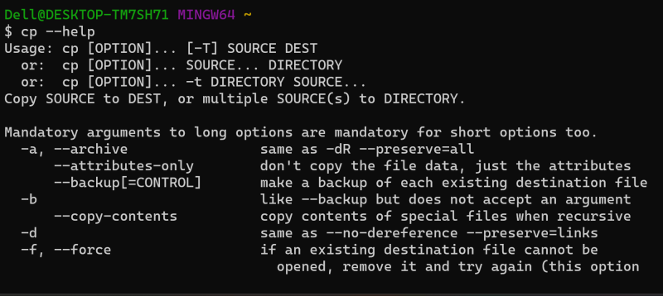
* Google <command> examples  
  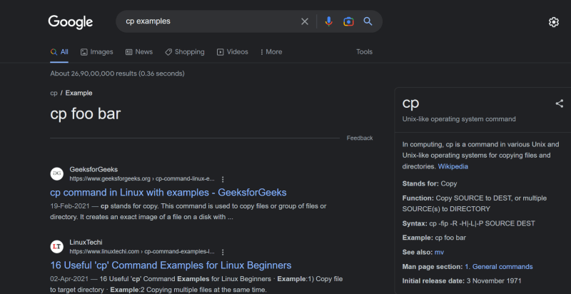

**Concept of user and home directory**

* When a user is created in any system a directory called as home directory will be created for the user where he has full permissions
* Tilde ~ on a terminal represents home directory

Windows: C:\Users\<username>

Linux: /home/<username>

Mac: /Users/<username>

* In command line dot . represents current directory and double dots .. represent parent directory